GEOL 3305

Chapter 16

Atmosphere Composition, Structure & Temperature

Earth's atmosphere

No other known planet has:

liquid water

substantial free oxygen
temperatures near the triple point of water (where liquid, gas, & solid meet)

Weather

The state of the atmosphere over short periods of time

Climate

Average weather conditions over long periods of time

Parameters

temperature

pressure
humidity
wind speed and direction
type and amount of precipitation
type and amount of clouds

Composition

Nitrogen 78.08%
Oxygen 20.95%
Argon 0.93%
Carbon dioxide 0.03% (increasing by .0001%/yr)
Water vapor 0 to 4%

Ozone near the surface <0.12 ppm (naaqs)
Ozone at 25 km altitude 1% 10,000 ppm

Ozone in the Upper Atmosphere

Ozone is created there by solar UV dissociating oxygen then recombining to form O₃

Ozone is destroyed by chlorine from CFC's & Nitrous Oxide (N₂O)
CFC (Chloro, Fluoro, Carbon) Gases e.g. Freon 12 (Dichlorodifluoromethane)

N₂O mostly comes from soils, 30% from fertilizer
N₂O destroyed by oxygen in upper atmosphere,
half life ≈120 years

CFC's half life ≈ 40 years, destroyed by UV sunlight in upper atmosphere

The ozone hole reached its maximum in 2009.

The Ozone hole will be healed by 2050, but at present it is causing the jet stream to move closer to the S. pole and causing increased global warming by stirring up the troposphere

Stratospheric Ozone filters out most of the ultraviolet radiation coming from the Sun. The Ozone hole makes us more susceptable to sunburn and cancer.

Carbon dioxide, Water vapor, CFC’s and Nitrous oxide absorb infrared (heat) energy
& heats the atmosphere

Dust and clouds reflect substantial sunlight

cools the atmosphere & earth's surface

volcanic eruptions are major sources of dust

Dust in the atmosphere serves as condensation nuclei

creates clouds

Despite our best efforts to reduce energy consumption, it
seems to precisely track the increase in population.

China has the most people, India is second and the United States is 3rd.
It will remain this way to at least 2050.

Extent and structure of the atmosphere

Pressure is due to weight of atmosphere above a point

Pressure decays exponentially with height
500 mb = 5.6 km altitude, average pressure at the Sea Level is 1,000 mb.
(diving to 8ft in a swimming pool increases pressure 25%)
So climbers have to use oxygen tanks for breathing when they climb Mount Everest
because there is less oxygen to breath. Everest is at 29,000 ft (8.8 km) altitude
so pressure there is about 300 mb so you would have to take 3.3 breaths to equal
one breath at sea level.

Atmospheric pressure is due to the weight of the atmosphere above that point. Likewise water pressure is due to the weight of the water above that point. So when there is a small amount of water or atmosphere above a point there is a small pressure.

The Ozone near the surface of the Earth (bad Ozone) damages the lungs of animals,
plants and rubber products (e.g. tires on automobiles).

The good Ozone is at about 25 km altitude.
Most clouds are below 11 km altitude.
Tropopause (minimum temperature) is at 11 km.
Another minimum temperature is at 90 km. This is where the space shuttle reenters the atmosphere where meteors burn up.

Radiosondes are used to measure the vertical structure of the atmosphere including temperature, pressure, and humidity.

Most important atmospheric phenomena occur in the troposphere
which is below 11 km.

Seasons

Rotation of the earth causes day and night.

Revolution of the earth about the sun (during the year) and tilt of axis of rotation together cause the seasons.

N. Hemisphere winter solstice in when the solar declination is -23.5 degrees

N. Hemisphere summer solstice is when the solar declination is +23.5 degrees

The earth is closest to the sun at perihelion (January 3)

When the Sun rises or sets the sunlight goes through more atmosphere and therefore the Sun will appear Redder than when the Sun is a local Noon when the sunlight goes through less atmosphere.

An equinox occurs when the solar declination is 0 degrees (when the Sun is over the equator)

Autumnal equinox in the fall, vernal equinox in spring

Tropic of cancer is +23.5 degrees

Tropic of capricorn is -23.5 degrees
Arctic and antarctic circles at ±(90-23.5) = ±66.5 degrees

For summer mid-latitudes in the northern hemisphere like Houston the Sun rises in the northeast and sets in the Northwest.

For Winter mid-latitudes in the northern hemisphere like Houston, the Sun rises in the Southeast and sets in the Southwest.

Radiation

Visible light is that seen with the naked eye

Ultraviolet light is shorter wavelengths than blue

Infrared light is longer wavelengths than red

All objects emit energy according to their temperature

Hot objects emit more energy

Clouds, water bodies, the ground are all good absorbers and emitters of all wavelengths of thermal radiation

Gasses are selective absorbers and so they have very narrow spectral absorption and emission lines

The Sun is the source of almost all heat on the Earth. All the heat we get from the Sun is by radiation.

Heat transfer

Conduction - molecular vibration (e.g. Holding a hot pan)

Convection - movement of mass of material (e.g. With a cloud)

Radiation - electromagnetic energy transport (e.g. Fireplace)

Windchill

wind flowing over the human body causes it to loose heat faster

This is the reason that ceiling fans are effective

Albedo - fraction of total radiation reflected

Diffused light - light that has its direction changed by a scattering medium

Shaded rooms are lighted by atmospheric scattering.

Atmosphere is:

a poor absorber of light in the visible

a good absorber of light in the infrared
stratosphere and mesosphere absorb ultraviolet

Energy from the Sun
50% is absorbed by the land and sea surfaces
20% is absorbed by the atmosphere and clouds
20% is reflected by the atmosphere and clouds
5% is reflected back to space by the atmosphere
5% is reflected back to space by the land-sea surface

Greenhouse effect

Due primarily to:

carbon dioxide

water vapor
cfc’s, HFC’s & nitrous oxide

A greenhouse is like a car in the sun. The sunlight comes through
the glass and heats things up. That energy can't get through the glass.

In the atmosphere, Carbon dioxide, water vapor and other gases are like the glass.
They hold in the heat.

Areas with less water vapor (deserts) have higher maximum temperatures and lower minimum temperatures

Temperature measurements

Most old meteorological stations measure
maximum temperature, pressure,
minimum temperature, rainfall
relative humidity

The automated new stations report continuously

Temperature, pressure, dewpoint, rainfall, visibility, ceiling height, wind direction, and wind speed.

Controls of temperature

Wind blowing from a colder or a warmer loction
Incoming solar radiation (latitude and clear or cloudy)

Evaporation

Reflection

Specific heat of surface

specific heat=amount of energy needed to raise 1 gm 1 deg c

Cities near large water bodies have seasonal temperature ranges reduced.

i.e. Galveston is warmer in winter and cooler in the summer than

if it were inland like Dallas. Likewise Chicago and Toronto are both

warmer in the winter than they would be if they weren't adjacent to a

large body of water.

Geographic position

leeward versus windward locations

marine versus continental

areas near the equator have constant day length year round
cloudy versus clear locations
(clouds reduce the daily range of temperature by acting like a blanket)
(likewise clear areas like deserts have a wide temperature range from day
to night)

So an area with clear skies during the day and clear skies at night would have
a very large temperature range (hot during the day and cool at night). Deserts
are like this.

An area with cloudy skies during the day and cloudy at night would have a small
temperature range. (Cooler during the day because the is not much sunlight and
warmer at night because the clouds act like a blanket).

Atmospheric pollution

Primary pollutants

co-49%

nox 15%
voc-14% (volatile organic compounds)

so2-16%

particles-6%

Sources

transportation-46%

stationary-27%
industrial-15%
solid waste disposal-2.5%
misc.-9%

Carbon Dioxide has increased 25% since 1850, due to combustion of fossil fuels.

1990 Clean Air Act
EPA to establish national standards

National Ambient Air Quality Standards (NAAQS)

Carbon Monoxide ( 9 ppm for 8 hours)
Lead (1.5 µg/m3) revised in 2006 (0.15 µg/m3)
NOx (0.053 ppm)
Ozone (0.12 ppm for 1 hour) revised in 2008 to .075 ppm
Sulfur Dioxide (0.03 ppm)
Particles less than 10 µm (50 µg/m3)
revised in 2006 2.5 µm or smaller (35 µg/m3)

Standards also established for 9 hazardous pollutants: Asbestos, Benzene, Beryllium, inorganic Arsenic, Mercury, radionuclides, Vinyl Chloride, coke oven emissions, Lead smelting and for 189 other materials.

EPA's 2012 annual report covering 1980 to 2012 indicated:
- lead levels decreased 99%
- sulfur dioxide levels fell 79%
- carbon monoxide levels declined 72%
- particulate (dirt, dust, soot) levels decreased 66%
- NOx levels fell 59%
- VOC dropped 57%.

-In cities up to 95% of carbon monoxide emissions are from automobiles.

- PM 2.5 Non attainment areas are in California and
- Hawaii, (VOG), Samoa, Guam, & Marianas

Controls of sulfur emissions enacted in 1990 have produced
43% drop in "wet" sulfate deposition in 2009, a key contributor to acid rain.

China has dense air pollution caused by coal powered electrical power plants. Ozone from China affects air quality at high altitudes in the U. S.

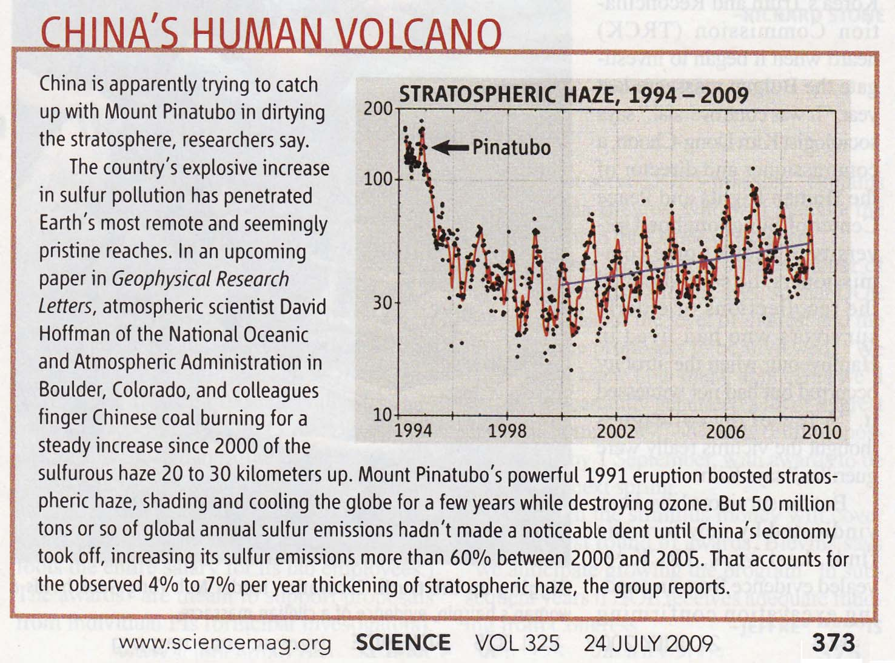
GEOL 3305

Chapter 16

GEOL 3305

Chapter 16

